Tasbi:Multisensory Squeeze and Vibrotactile Wrist Haptics for Augmented and Virtual Reality

【Summary】：

In this work, we present Tasbi, a multisensory haptic wristband capable of delivering squeeze and vibrotactile feedback. The device features a novel mechanism for generating evenly distributed and purely normal squeeze forces around the wrist. Our approach ensures that Tasbi’s six radially spaced vibrotactors maintain position and exhibit consistent skin coupling. In addition to experimental device character-ization, we present early explorations into Tasbi’s utility as a sensory substitution device for hand interactions, employing squeeze, vibration, and pseudo-haptic effects to render a highly believable virtual button.

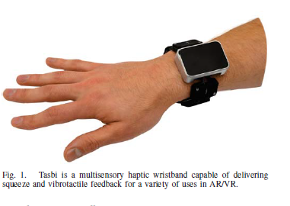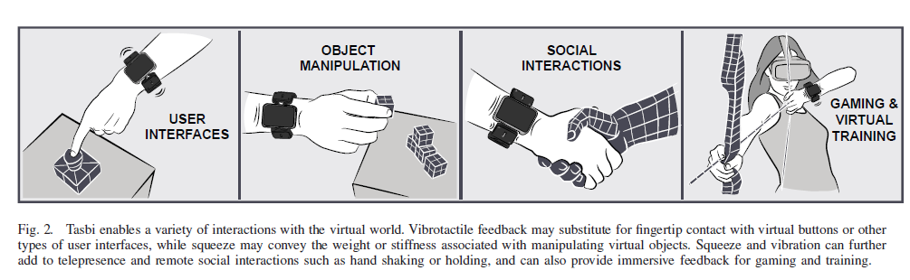

【Two feedbacks included in the device】：

Vibrotactile Feedback

Squeeze Feedback

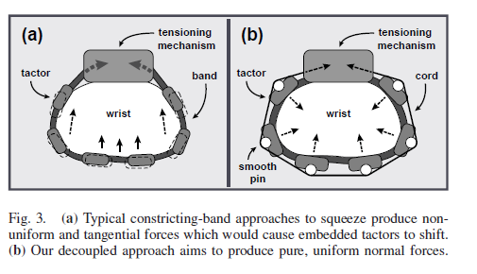 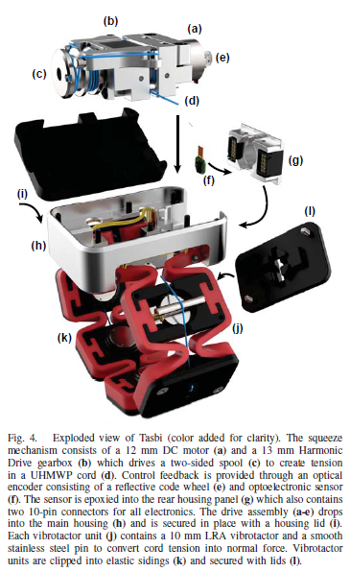

【Tasbi】：

The overall dimensions of the watch are approximately 50 × 50 × 15 mm and the total weight is less than 200 grams.

1. Squeeze Mechanism
2. Vibrotactile Band
3. Feedback and Control

【SQUEEZE CHARACTERIZATION】：Testing the squeeze of equipment.

【MULTISENSORY VR INTERACTIONS】：Test the device in an AR / VR environment.

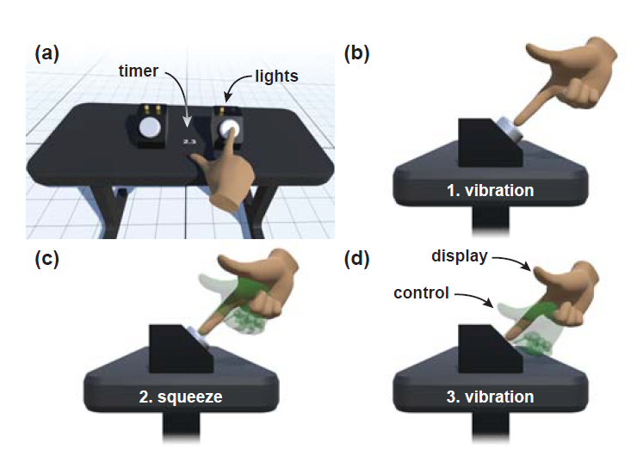

【Conclusion】：

To conclude, we have presented Tasbi, a haptic wristband featuring multisensory squeeze and vibration for AR/VR interactions. The device produces evenly distributed forces up to 15 N and 10 Hz radially around the wrist. Importantly, our design eliminates tangential shear forces which would have otherwise presented problems for band embedded vibro-tactors. Finally, we presented a proof of concept application in which squeeze, vibration, and a psuedo-haptic effect were utilized to create a highly believable ﬁnger-button interaction.

【Important Reference】:

C. Pacchierotti et al., “Wearable haptic systems for the ﬁngertip and the hand: Taxonomy, review, and perspectives,” IEEE Trans. Haptics, vol. 10, no. 4, pp. 580–600, Oct 2017.

J. Perret and E. Vander Poorten, “Touching virtual reality: a review of haptic gloves,” in ACTUATOR Conf., June 2018, pp. 1–5.

F. Chinello et al., “The HapBand: A cutaneous device for remote tactile interaction,” in Haptics: Neuroscience, Devices, Modeling, and Applications, M. Auvray and C. Duriez, Eds. Berlin, Heidelberg: Springer, 2014, pp. 284–291.

T. K. Moriyama et al., “Development of a wearable haptic device that presents haptics sensation of the ﬁnger pad to the forearm,” in IEEE Haptics Symp., March 2018, pp. 180–185.

B. Stephens-Fripp et al., “Applying mechanical pressure and skin stretch simultaneously for sensory feedback in prosthetic hands,” in IEEE Intl. Conf. Biomed. Robot. and Biomech., 2018, pp. 230–235.